**Project Design Phase-II**

**Solution Requirements (Functional & Non-functional)**

|  |  |
| --- | --- |
| Date | 1.11.2023 |
| Team ID | NM2023TMID08614 |
| Project Name | Create a google business page |

**Functional Requirements:**

|  |  |  |
| --- | --- | --- |
| **Sl No.** | **Functional Requirement** | **Sub Requirement (Story / Sub-Task)** |
| 1 | **User Registration and Authentication:** | * + - * The system should allow businesses to register for a Google Business Page.       * Users should be able to log in securely using their Google accounts or create a new account if they don't have one. |
| 2 | **Business Information Input:** | * + - * Users should be able to input accurate business details, including name, address, phone number, website,categories, and attributes.       * A description section should allow users to provide a brief overview of their business. |
| 3 | **Location and Service Area:** | * + - * For physical businesses, users should be able to specify the exact location on Google Maps.       * For service-area businesses, users should be able to specify the regions they serve. |
| 4 | **Media Upload:** | * + - * Users should be able to upload high-quality images and videos showcasing their business, products, services, and team members.       * The system should support various media formats and provide guidelines for optimal resolution and format. |
| 5 | **Business Hours:** | * + - * Users should be able to set regular business hours and specify special hours for holidays or events.       * The system should allow businesses to indicate if they are temporarily closed for renovations, holidays, or other reasons. |
| 6 | **Customer Engagement Features:** | * + - * Users should be able to manage customer reviews, including responding to reviews and ratings.       * The system should allow businesses to post updates, events, promotions, and offers to engage with customers. |
| 7 | **Integration and Verification:** | * + - * The system should integrate with the Google My Business API to enable seamless management of business information.       * Users should be guided through the verification process, which may include phone verification or mail verification. |
| 8 | **Content Moderation and Policies:** | * + - * Implement content moderation tools to filter inappropriate content in reviews and posts.       * Provide guidelines to users regarding Google's policies to prevent violations. |
| 9 | **Mobile Accessibility:** | * + - * Ensure the system is accessible and user-friendly on mobile devices, allowing users to manage their Google Business Page via smartphones and tablets. |
| 10 | **Analytics and Insights:** | * + - * Provide businesses with access to analytics and insights, including the number of views, clicks, and customer interactions on their Google Business Page.       * Present data in a clear and understandable format, allowing businesses to measure their online presence's effectiveness. |
| 11 | **User Support and Help Center:** | * + - * Offer a user support system where businesses can seek assistance for any issues related to creating or managing their Google Business Page.       * Provide a comprehensive help center with FAQs, tutorials, and guides to assist users in utilizing the platform effectively. |

**Non-functional Requirements:**

Following are the non-functional requirements of the proposed solution.

|  |  |  |
| --- | --- | --- |
| 1 | **Performance:** | * + - * The system should respond to user interactions within 2 seconds, ensuring a responsive user interface.       * The system should handle a minimum of 1000 concurrent users without performance degradation. |
| 2 | **Scalability:** | * + - * The system should scale horizontally to accommodate a growing number of businesses without significant architectural changes.       * It should support at least a 20% increase in the number of registered businesses within a year. |
| 3 | **Reliability:** | * + - * The system should have an uptime of 99.9% to ensure businesses can access and manage their Google Business Pages reliably.       * It should have automated backup and recovery processes to prevent data loss in case of system failures. |
| 4 | **Security:** | * + - * User data, including login credentials and business information, should be encrypted both in transit and at rest to ensure data confidentiality.       * The system should have measures in place to prevent unauthorized access, including secure APIs and proper access controls. |
| 5 | **Usability:** | * + - * The user interface should be intuitive and user-friendly, requiring minimal training for business owners to manage their Google Business Pages effectively.       * The system should provide clear error messages and guidance to users in case of input errors. |
| 6 | **Compliance:** | * + - * The system should comply with data protection regulations, ensuring that user data is handled in accordance with privacy laws.       * It should comply with Google's API usage policies and guidelines to prevent any service interruptions. |
| 7 | **Reliability:** | * + - * The system should be reliable, with a mean time between failures (MTBF) of at least 500 hours.       * It should have mechanisms for logging and tracking errors, allowing quick identification and resolution of issues. |
| 8 | **Documentation and Support:** | * + - * Provide comprehensive user documentation to guide businesses through the process of setting up and managing their Google Business Pages.       * Offer responsive customer support to address user queries, issues, and feedback in a timely manner. |
| 9 | **Interoperability:** | * + - * Ensure that the system can integrate seamlessly with other platforms and services, allowing businesses to synchronize their information effortlessly. |
| 10 | **Performance Monitoring and Reporting:** | * + - * Implement performance monitoring tools to track system performance, usage patterns, and response times.       * Generate regular reports detailing system uptime, usage statistics, and user engagement metrics for analysis and improvement. |

**REQUIREMENT ANALYSIS (FLOW CHART):**

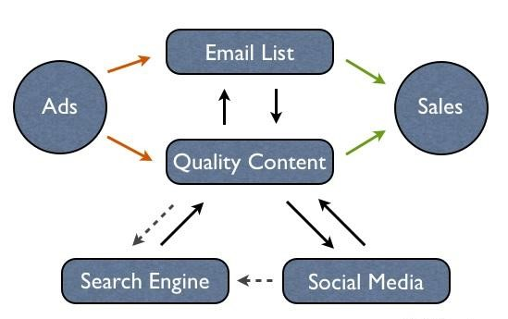

**TECHNICAL ARCHITECTURE:**

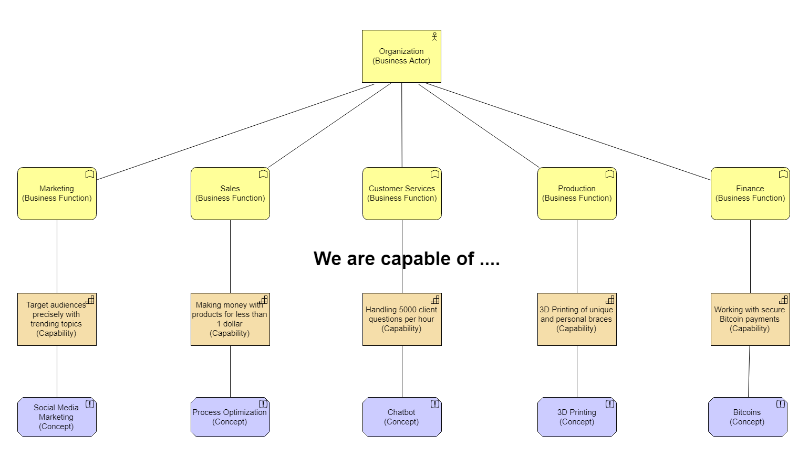

**OPEN-SOURCE FRAMEWORKS:**

**1. WordPress:**

WordPress is a widely-used open-source content management system (CMS) that allows users to create websites, including business pages, through customizable themes and plugins.

**2. Joomla:**

Joomla is another open-source CMS that offers flexibility and ease of use. It's suitable for building business websites and includes various extensions and templates.

**3. Drupal:**

Drupal is a powerful open-source CMS known for its flexibility and scalability. It's suitable for building complex websites, including business pages with advanced features.

**4. Magento:**

Magento is an open-source e-commerce platform that businesses can use to create online stores and manage products, orders, and customer interactions.

**5. Grav:**

Grav is a modern open-source flat-file CMS that doesn't require a database. It's designed for simplicity and speed, making it suitable for smaller business websites and blogs.

**THIRD PARTY API**

1. **Google Maps API:**

Google Maps API allows businesses to embed interactive maps on their website, helping customers find their physical locations easily.

1. **Google Places API:**

Google Places API provides detailed information about places, including business names, addresses, user ratings, reviews, and photos.

**3. Google Reviews API:**

Google Reviews API allows businesses to access and display Google reviews on their website.

1. **Stripe API:**

Stripe API enables businesses to securely process online payments and manage subscriptions.

**5.Zendesk API:**

Zendesk API allows businesses to integrate customer support features, including tickets, chat, and knowledge base.

**CLOUD DEPLOYMENT:**

**1. Choose a Cloud Service Provider:**

Select a reliable cloud service provider such as Amazon Web Services (AWS), Microsoft Azure, Google Cloud Platform (GCP), or others based on your specific requirements, budget, and geographical preference

**2. Design and Develop Your Website:**

Develop your business website using web development technologies and frameworks. Ensure that your website is mobile-friendly, responsive, and optimized for fast loading times.

**3. Data Storage and Databases:**

Store your website files, images, and multimedia content in cloud storage services provided by the cloud provider. For dynamic websites, set up databases in managed database services like Amazon RDS (Relational Database Service) or Azure Database for MySQL/PostgreSQL.

**4. Content Delivery Network (CDN):**

Utilize a Content Delivery Network (CDN) service to distribute your website's static and dynamic content to servers located strategically around the world. This ensures fast content delivery to users, improving website performance.

**5. Security and Compliance:**

Implement security best practices, such as SSL/TLS encryption for data in transit, firewall rules, and access controls. Ensure compliance with data protection regulations relevant to your business.

**6. Load Balancing and Scalability:**

Set up load balancers to distribute incoming traffic across multiple servers, ensuring high availability and fault tolerance. Implement auto-scaling solutions to automatically adjust server resources based on demand.

**7. Backup and Disaster Recovery:**

Regularly back up your website data and configurations. Implement disaster recovery strategies to ensure business continuity in case of unexpected incidents.

**8. Monitoring and Analytics:**

Implement monitoring tools and analytics services to track website performance, user interactions, and server health. Use this data to optimize your website and user experience continually.

**9. Link to Your Google Business Page:**

Ensure that your business website is linked to your Google Business Page. Add relevant links, contact information, and a map with directions to your physical location (if applicable) on your website.

**10. Regular Maintenance and Updates:**

Regularly update your website content, security configurations, and software components. Monitor your website's performance and user feedback, making necessary improvements to enhance user experience.